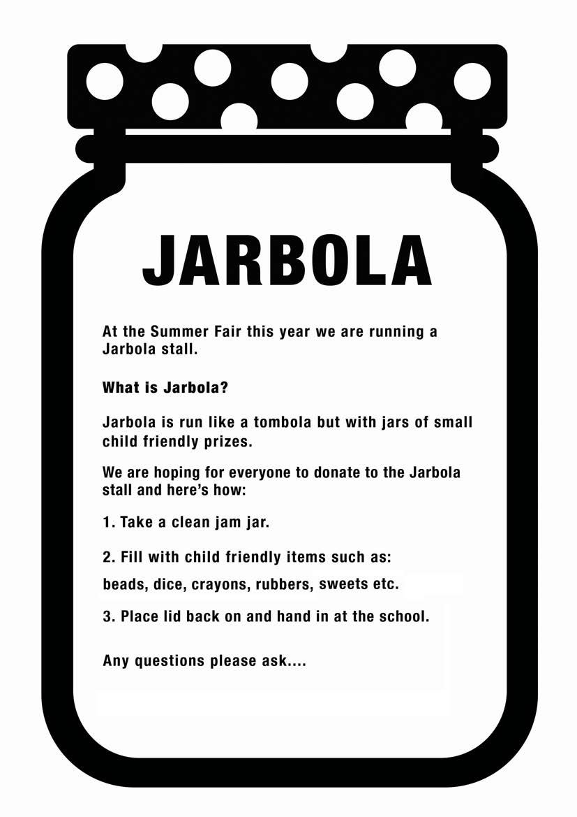

At the Christmas fair we are running a Jarbola stall.

**What is Jarbola?**

Jarbola is run like a tombola but with jars of small child friendly prizes.

We are hoping for everyone to donate to the Jarbola stall and here is how:

1. Take a clean jam jar
2. Fill with child friendly items such as:

beads, dice, crayons, rubbers, sweets etc.

1. Place lid back on and hand in at the school.

Any questions please ask……